WEB Quest 100 File Types Digital images
Items in blue offer some information and notes and items underlined are links to help you get answers you should find more links on the Internet to help you answer questions
Questions are numbered and may be highlighted = answer where you see this Answer: (there are 11 questions to answer)
You should read lesson: LES134 Image Files and Size.doc before undertaking this web quest.

File Types Digital image basics web quest
Images are objects that communicate meaning or information. If an image is to be used on a computer, it must be in a digital form.
Images used on computers can be classed as either natural or artificial. A photograph is an example of a natural image. Once the photograph has been digitized (converted into numbers) a computer can store, process and manipulate the image.
Artificial images are those that have been created entirely on a computer using computer processes. There are many programs available for creating artificial digital images and graphics.
Computers have two formats for displaying and processing digital images. These two formats are vector and raster.
Your Name

Save this file as yoursurnameWBQ100.doc

1. Which image files would you to use? For EMAIL
Answer:
http://www.techterms.com/

2. Explain the difference between Vector image and Raster images?
https://pc.net/helpcenter/answers/vector_and_raster_graphics
Vector images Answer:


Raster images Answer:

Insert a new vector image here
Answer:
Insert a new raster image here
Answer:

3. Explain the attributes of the following file types, include advantages and disadvantages
https://en.wikipedia.org/wiki/Image_file_formats
www.askjeeves.com and type Graphics Formats into the ask box.
Movie / video formats. There are a number of formats for displaying video on computers. Again, some are suitable for some applications, such as power point, and others are best for the web. You are to research 3 video formats. For the following file types, find out what the extension stands for; what are the characteristics of the file type, and where would you use it. File types to be covered are:
Windows Bitmap (.bmp)
Answer:

 | Advantages | Disadvantages
Quality
Colours
Compatibility
File Size
Useful for
Other
Sample:

Tagged Image File Format (.tif)
Answer:

 | Advantages | Disadvantages
Quality
Colours
Compatibility
File Size
Useful for
Other
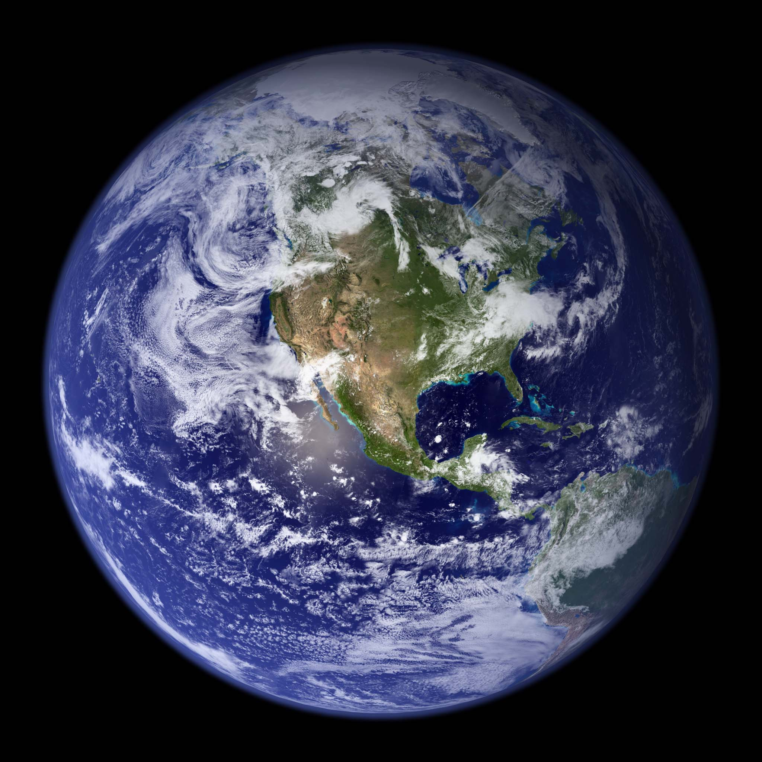
Sample:

Joint Photographic Experts Group – JPEG (.jpg .jpeg .jpe)
Answer:

 | Advantages | Disadvantages
Quality
Colours
Compatibility
File Size
Useful for
Other

Sample:
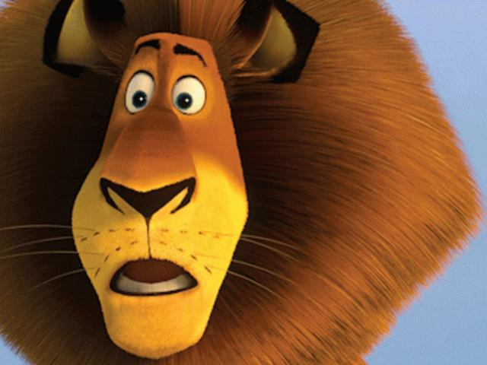

Graphic Interchange Format (.gif)
Answer:

 | Advantages | Disadvantages
Quality
Colours
Compatibility
File Size
Useful for
Other

Sample:


Portable Network Graphic (.png)
Answer:

 | Advantages | Disadvantages
Quality
Colours
Compatibility
File Size
Useful for
Other

Sample: 

4. Open a hi-res image or find a High Resolution Image on the internet and or use the bottle300dpi image (copy from WBQ 100 images folder)
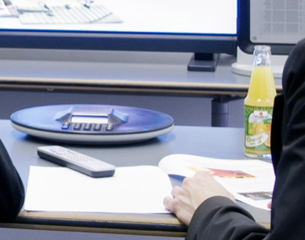

Using Photoshop re-sample it by changing Image Size -
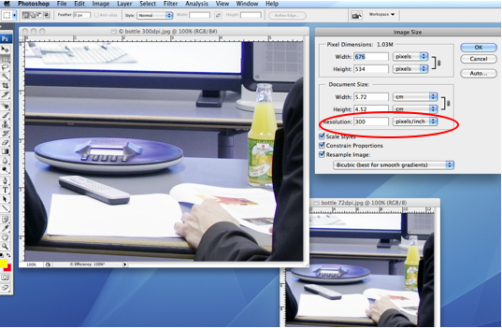
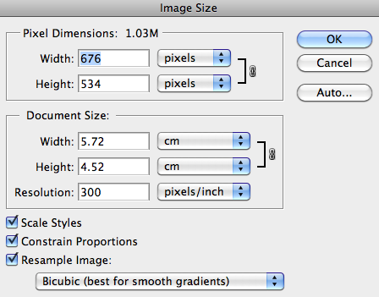

Compare Pixel Dimensions note the change in size
and

5. Change the pixels to 100 bring both images side by side
6. Change the dpi from 300 to 72dpi (pixels/inch)

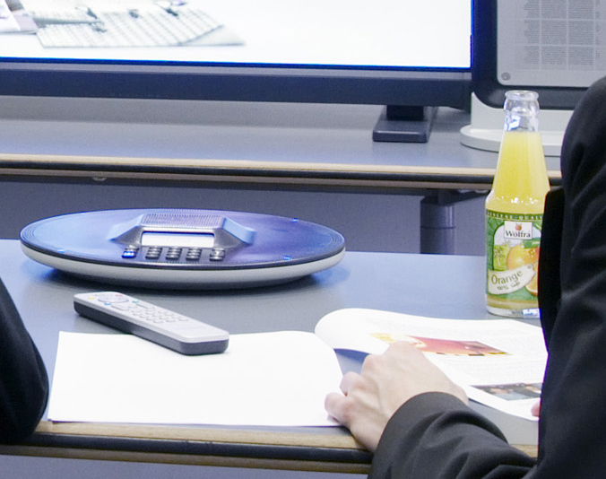
300dpi (pixels/inch) 72dpi (pixels/inch)

Compare images as per sample below

Sample
Image Quality
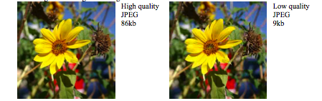
High quality  JPEG  86kb | Low quality  JPEG  9kb

7. Find a .bmp image on the internet insert it here:
Answer: insert image

8. Use Word or Photoshop to create the shape below. Fill the shape with a colour of your choice.

Copy the image paste it into a drawing program
If you save the file under different formats - complete the table below by examining the properties of each file.
Format | No. of Colours | File size (Kb)
BMP
PNG
GIF

Write a short paragraph summarising your results.

8. What are the advantages of the vector image format over the raster image format.

9. Use the properties from your graphics package to complete the table below, include HSL.
Note: Click on a colour then select the color and go to More Colours… Use the drop down to see differences

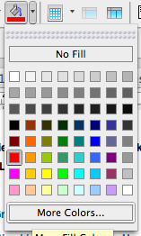

RGB = Red Blue Green
HSL = Hue Saturation Lightness or HSV = Hue Saturation (value) or HSB
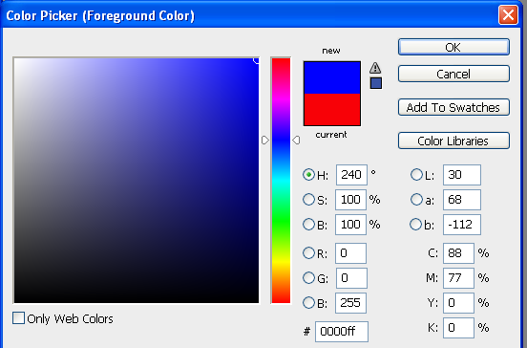
In Photoshop HSL = HSB (Brightness)

Insert at least 3 colours RGB, HSB (V) or CMYK and show findings for (RGB and HSB or CMYK levels) (I have done the Red colour for you se below
 | R | G | B | H | S | B | C | M | Y | K
RED | 255 | 0 | 0 | ?? | ?? | ?? | ?? | ?? | ?? | ??
BLUE | ?? | ?? | ?? | ?? | ?? | ?? | ?? | ?? | ?? | ??
GREEN | ?? | ?? | ?? | ?? | ?? | ?? | ?? | ?? | ?? | ??
Pick any colour | ?? | ?? | ?? | ?? | ?? | ?? | ?? | ?? | ?? | ??
BLACK | ?? | ?? | ?? | ?? | ?? | ?? | ?? | ?? | ??
WHITE | ?? | ?? | ?? | ?? | ?? | ?? | ?? | ?? | ??
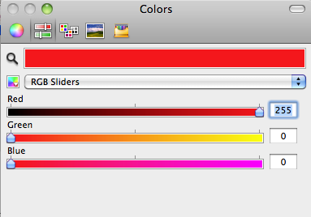
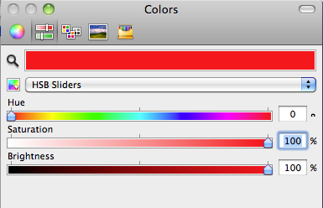
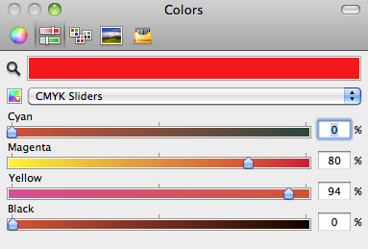

Question 10
- What does CMYK stand for?
C
M
Y
K
Question 11
11. What is the difference between Lossy and lossless image compression?

Lossy

Lossless
12. Give the name of a program that can edit / create each of the above types.

13. For all of the file types below, find out whether it is a bit mapped or vector graphic; what the extension stands for; what are the characteristics of the file type, and where would you use it. EG: Power Point; web page.
File | Stands For | Type B or V | Characteristics | Uses
BMP | Bitmap | Bitmap | This is a high quality picture format, but also results in a large file size | They can be used in Word documents or photo programs, but not on web pages.
GIF;
TIFF;
PNG
PSP;
JPG

For example, BMP stands for Bitmap. This is a high quality picture format, but also results in a large file size (Why?). They can be used in Word documents or photo programs, but not on web pages. Include a small (250 X 250 pixels) picture example of each file in your assignment.

SHOW EXAMPLES of Different image types
Use Photoshop (Previous lessons)

Or

Getting started with Corel Draw:

- Open Corel Draw, new page
- Layout, Page Setup, resize to PIXELS 800 x 600
- Import photo – File, import, select your photo, top corner click and stretch to fit page
- Look at layers (right hand side)
- Layers must be visible (If not, Window, Dockers, Object Manager)
- Each feature gets a new layer
- 2 main tools to draw with (continuous line), (click, click, more control)
- If shapes won’t fill then they are not properly closed (i.e. colour bleeds out)
- Use the colour sample box to match shades of colour
- Explain layers (colours, fill, etc) - shift layers up or down the list in front/behind
- Easier to begin with most fore-front face features

References:

http://www.scala.com/multimedia/multimedia-directory.html
http://computer.howstuffworks.com/question408.htm

References:

* Getting started in digital photography
* Tips and info on graphics, imaging, and digital photography
* JPG v's GIF for web images
* How bad is JPG? (Large file)
* Should you use JPG or a lossless format for archiving images? (Large file.)
* Chroma sub-sampling in JPG
* Miscellaneous tips and info

Video Man program: Help – Clips – Types of Video Data.
Virtual Dub program: Help – Contents – Intro to Digital Video
PC Tec Guide http://www.pctechguide.com/24digvid.htm
Ask Jeeves – Digital Video in Ask box.

Sources
www.digicamhelp.com
www.webopedia.com

